MongoDB -Aggregation Exercises

1. use db.zipcodes.find() to filter results to only the results where city is ATLANTA and state is GA

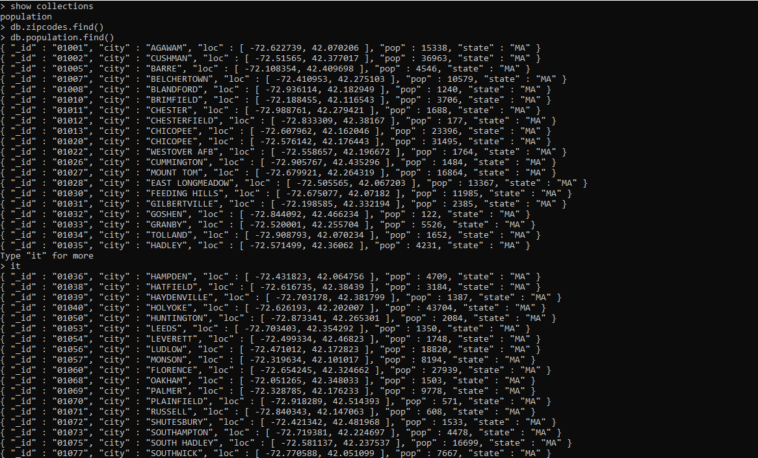

1. use db.zipcodes.aggregate with $match to do the same as above.

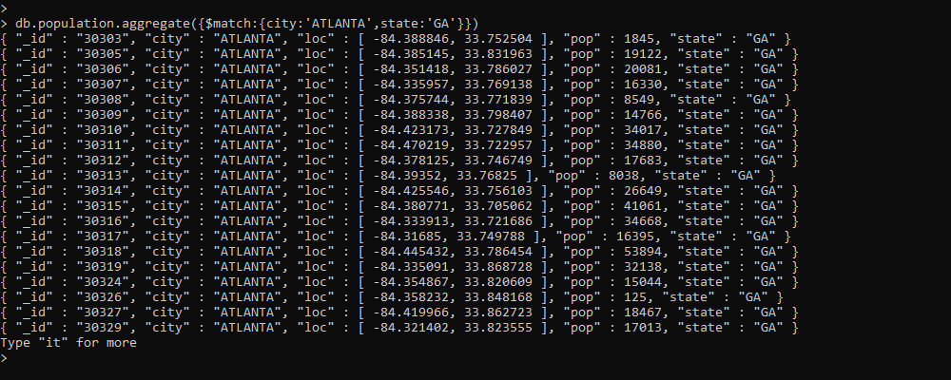

1. use $group to count the number of zip codes in Atlanta.

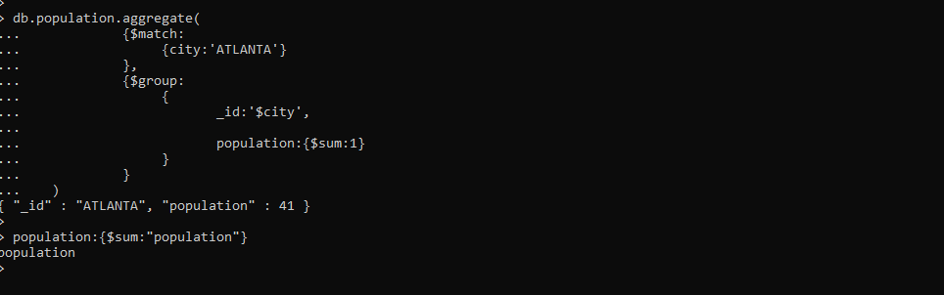

Populations by State

1. use aggregate to calculate the total population for each state

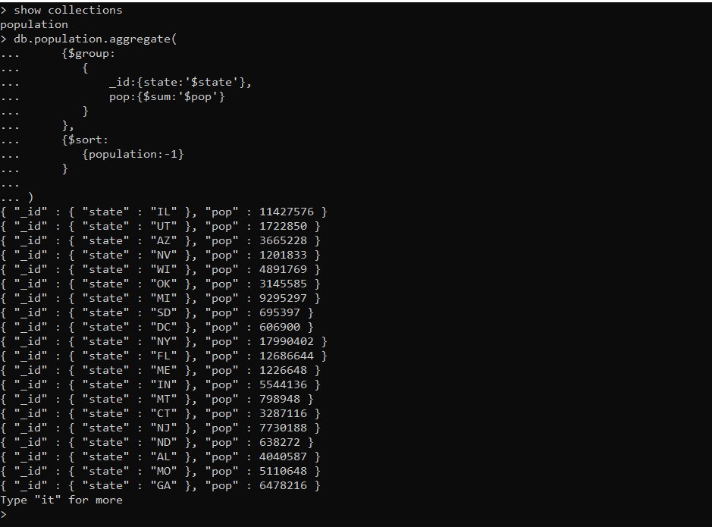

Populations by City

1. use aggregate to calculate the total population for each city (you have to use city/state combination). You can use a combination for the _id of the $group: { city: '$city', state: '$state' }

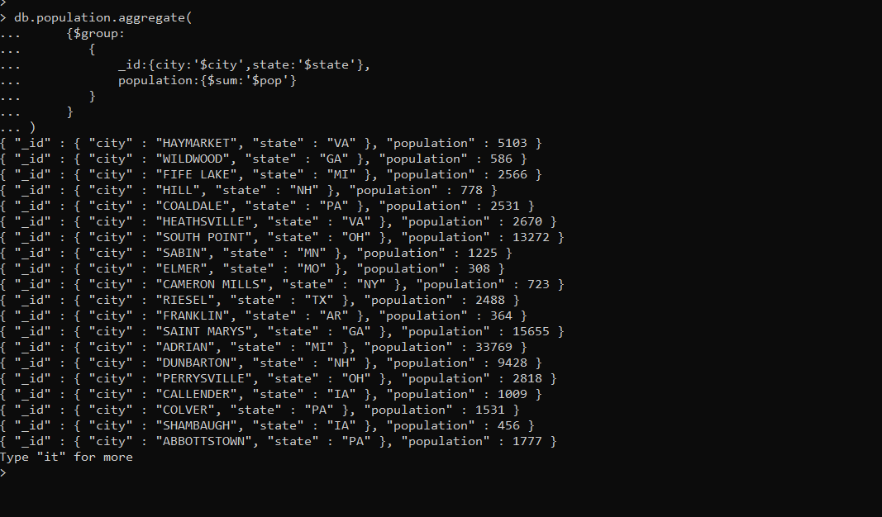

1. sort the results by population, highest first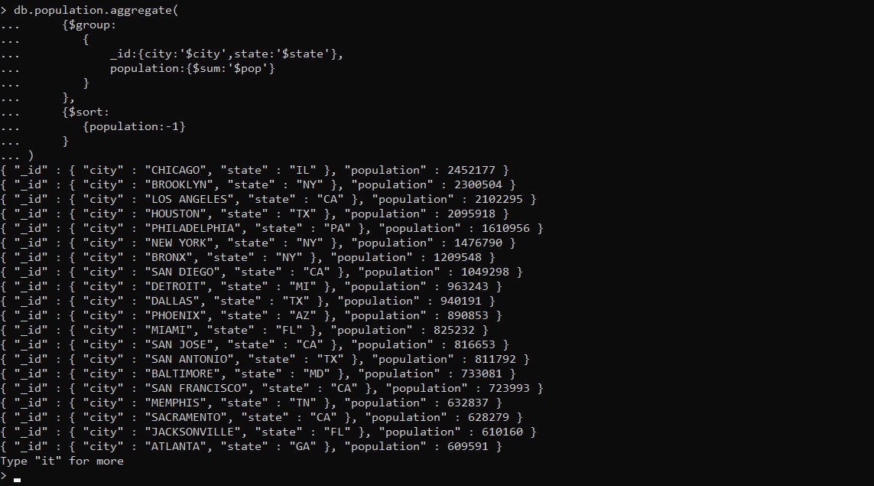

Bonus

1. Write a query to get the average city population for each state

